Version Control Setup Instructions

Programming Fundamentals with C#

SPRING SEMESTER 2019

horizontal line

# Create an account on bitbucket.org

1. Open <https://bitbucket.org/>
2. Select "Get Started"

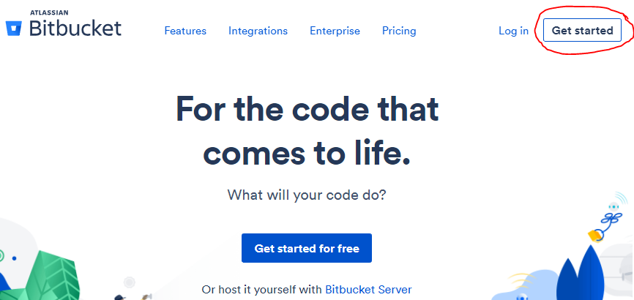

1. Enter your **ranken email address** and press continue.

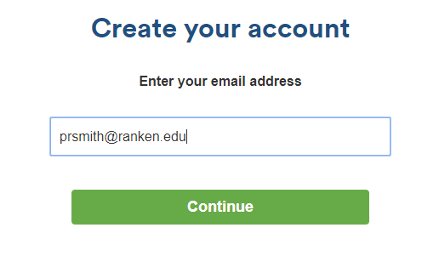

1. Enter your **full name** and create a password. Then press continue.

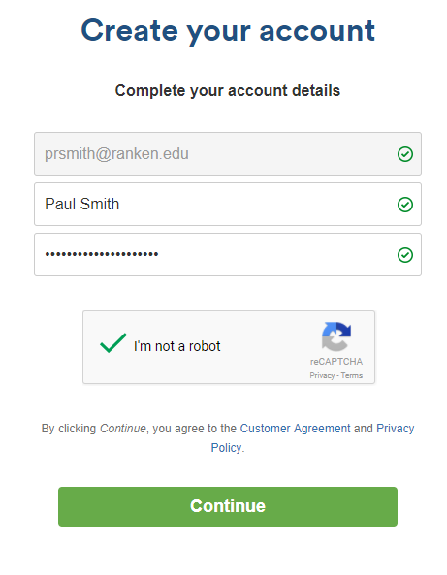

1. Log into your ranken email and verify your email address. (<https://mail.ranken.edu>)
2. **Your username must be in the format firstname_lastname (followed by a number if needed).**

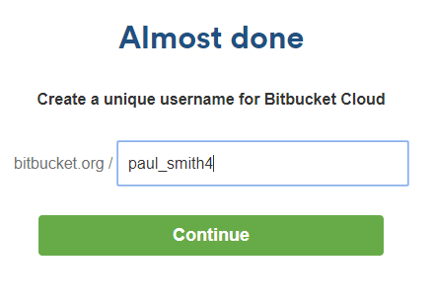

1. Congratulations, your account should be setup now!

# 

# 

# Install TortoiseGit

*Note for Mac users: TortoiseGit only supports Windows. You will need to install this in your Windows VM. Install the SourceTree client if you don't have a VM setup yet. (*[*https://www.sourcetreeapp.com/*](https://www.sourcetreeapp.com/)*)*

1. Open <https://git-scm.com/downloads>
2. Download the proper version for your operating system.

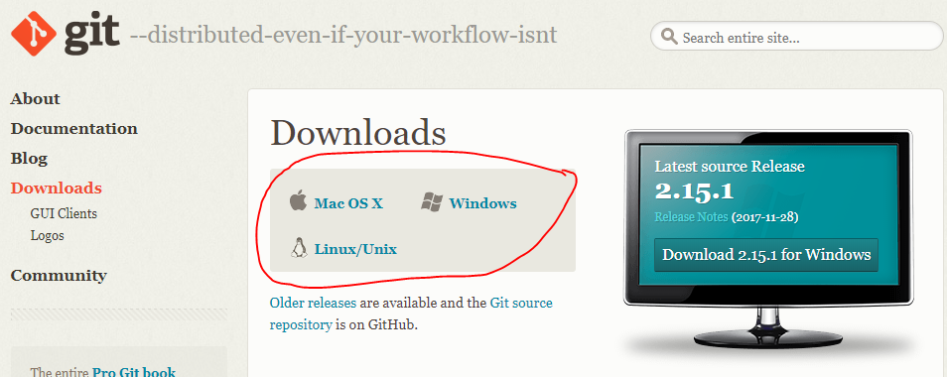

1. Open <https://tortoisegit.org/download/>
2. Download the proper version for your operating system.

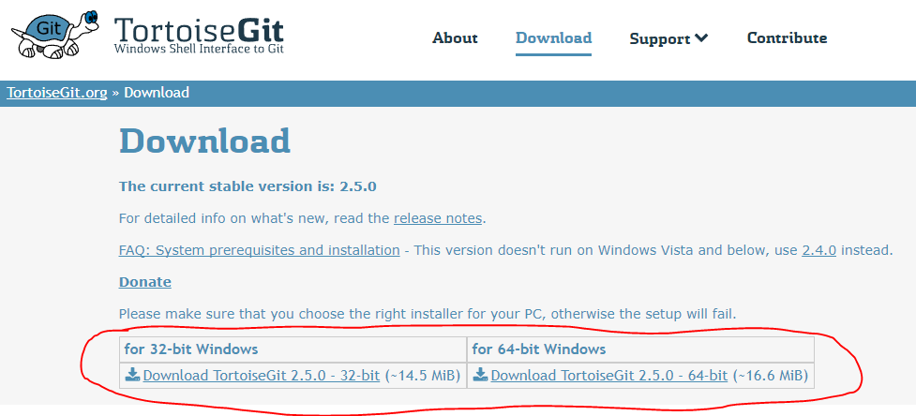

1. Run the **Git SCM** installer *first.*
2. Accept all the default options.
3. When the previous install is completed (not before), run the **TortoiseGit** installer.
4. Accept all the default options.
5. Right-click on your desktop. If you see an option labeled **"TortoiseGit",** then the install was successful. If not then reboot your machine.

# Install Notepad++

1. Open <https://notepad-plus-plus.org/>
2. Download the latest installer for Notepad++

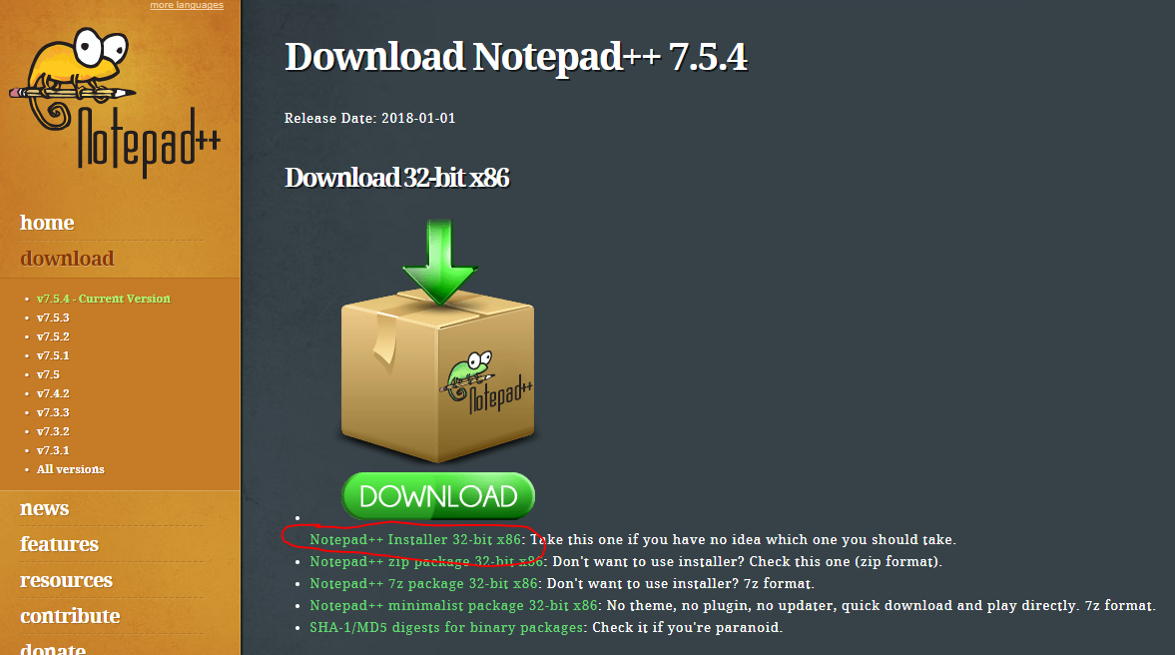

1. Run the installer and accept all the default options.

# 

# Create a remote repository

1. Select **Create a repository**
2. **Name the repository "cs_spring2019"**
3. **Check the box for "This is a private repository"**
4. **You do not want a README file to be included. Creating one now will cause issues later in the process.**

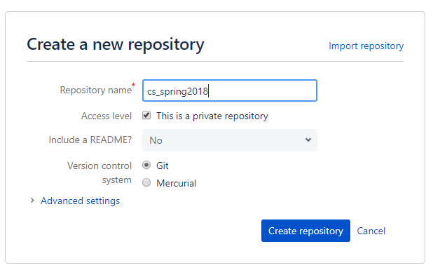

1. Press **Create repository**
2. Select "Settings"

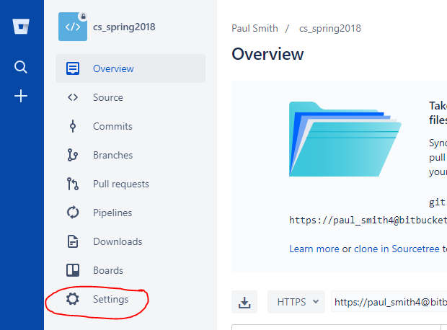

1. Select "User and group access"

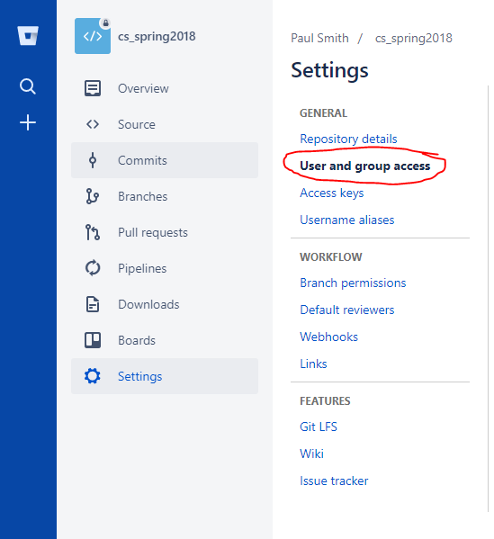

1. **Search for "Evan A Gudmestad" and add me with *Admin* access.**

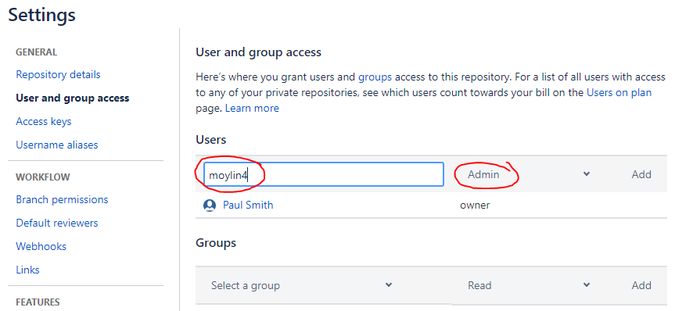

# 

# 

# Create a local repository

1. Create a folder named **cs_spring2018** where you will put all of the code for your assignments this semester. (Labs and Hands-On-Tests.)

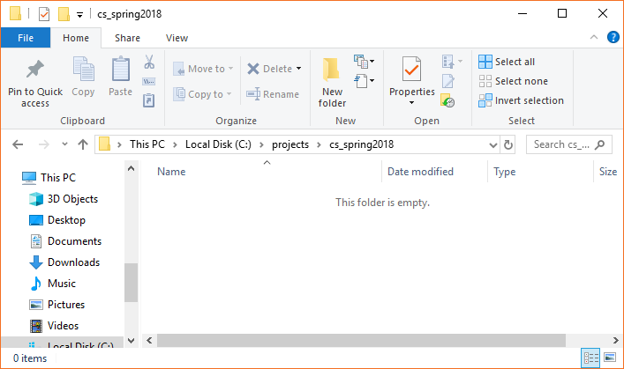

1. Select **View > Options > Change folder and search options**
2. Select the **View** tab
3. Select **Show hidden files, folders, and drives**
4. Uncheck **Hide extensions for known file types**
5. Press **OK**

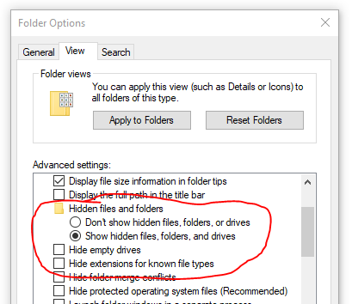

1. Right-click in the folder and select **"Git create repository here..."**

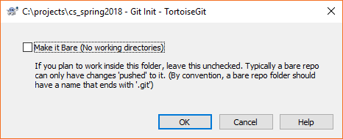

1. Select OK
2. You should now see a folder named **.git**

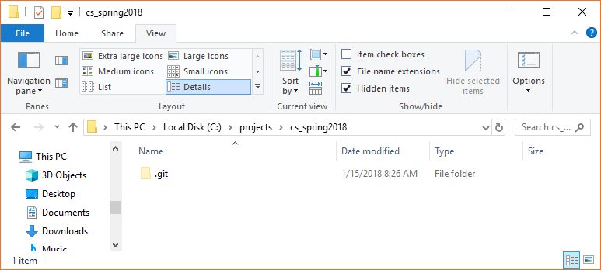

1. Now we need to setup your ignore file.
2. **Download the gitignore file on InsideRanken**
3. **Use command prompt to rename gititnore to .gitignore**

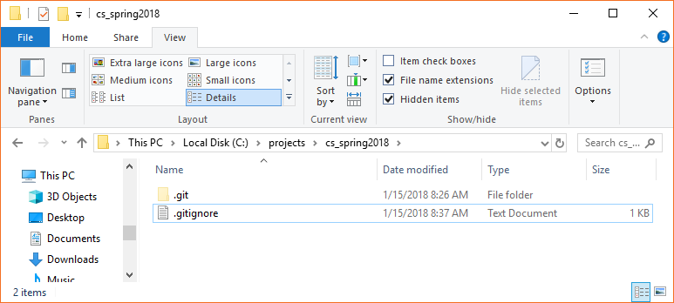

1. Right-click the **.gitignore** file and select **Edit with Notepad++**
2. Verify that the contents are as shown below.

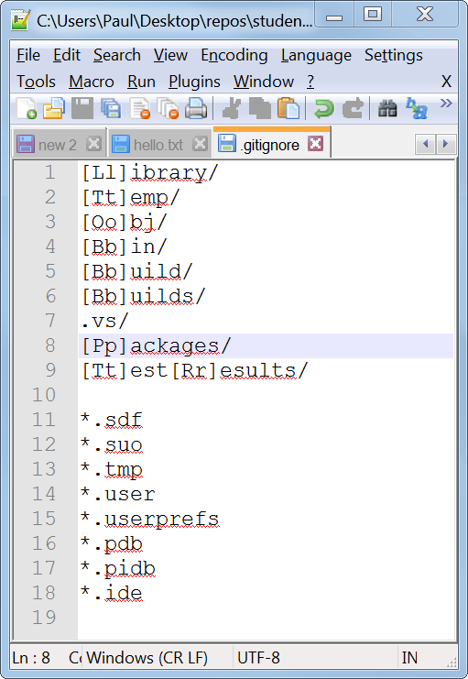

1. Now move all of the solutions for your labs and hands-on-tests into this folder.

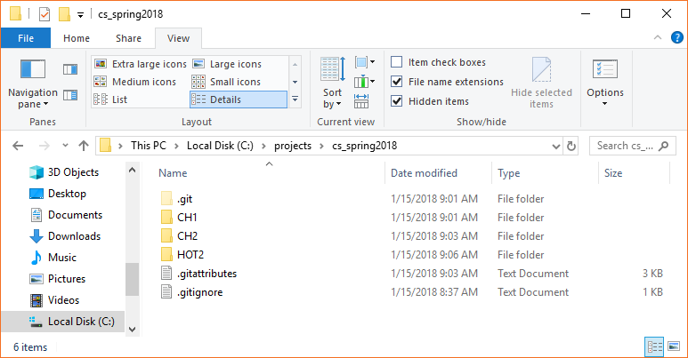

1. *Please create all future projects (except final project) under this folder.*
2. Right-click in the empty space of the folder.
3. Select **TortoiseGit > Settings**
4. Select **Git > Remote**
5. Paste in your remote URL from the website.

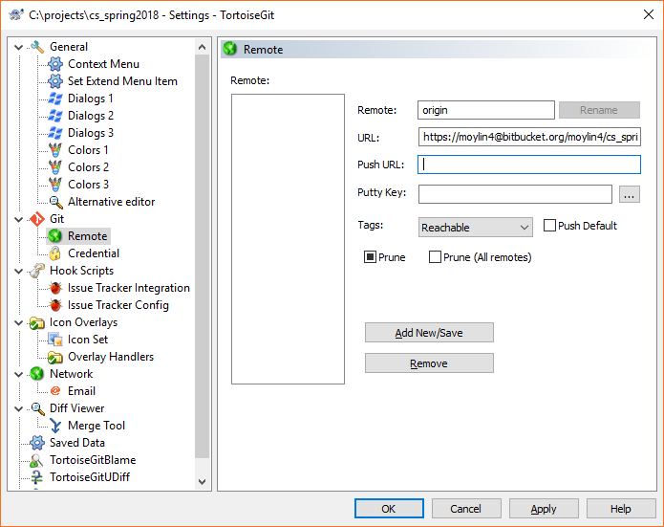

1. Select **Add New/Save**
2. Select **OK**

# Commiting and Pushing your code

1. Right-click in the folder again
2. Select **Git Commit -> "master"...**
3. Select **All** files and enter a comment
4. Select **Commit**

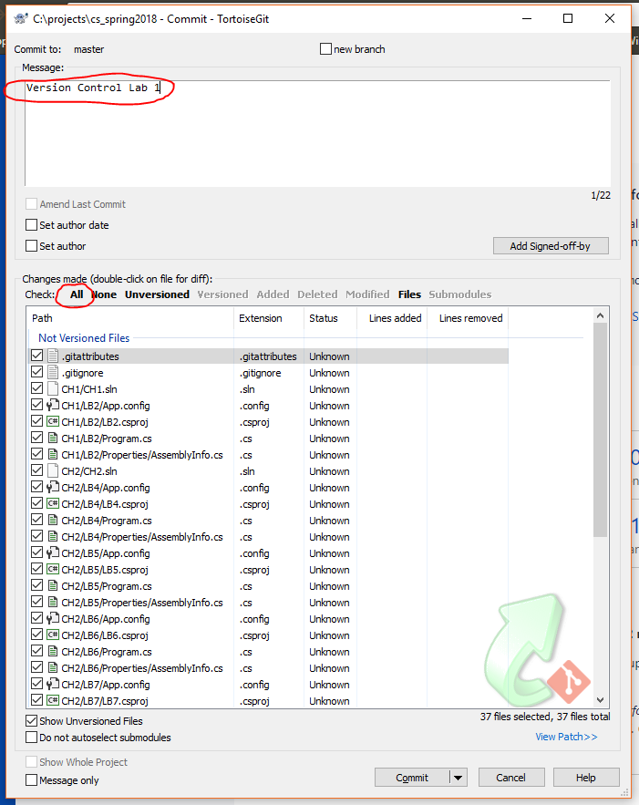

1. Select **Close** when the process is complete

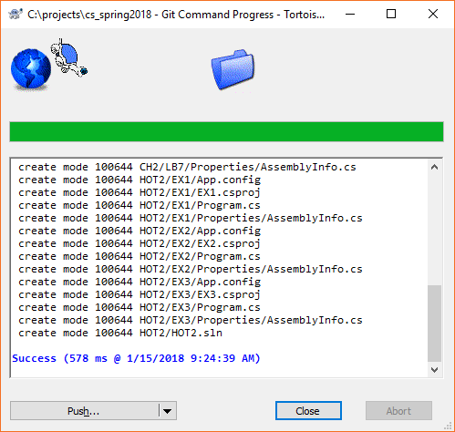

1. Right-click in the folder again
2. Select **Git Sync…**
3. Enter **master** for the Remote Branch
4. Select **Push**

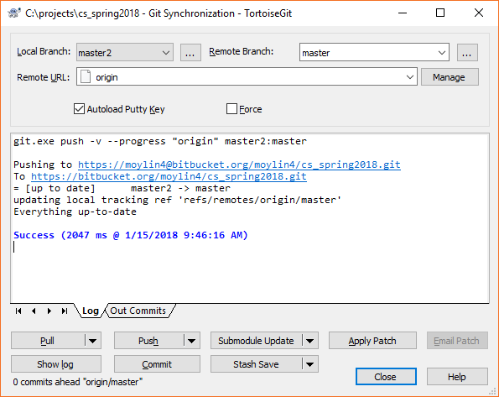

1. **Your code should now be uploaded to bitbucket :)**
2. Please fill out the version control lab handout and return to your instructor, so that we can double-check it.